Any Time At All the Beatles edited 11/17/2022

[Chorus]
N.C. Bm Bm7 Bm D
Any time at all
A Asus4 A Asus2 A
Any time at all
Bm
Any time at all
G
All you got to do is call
A Dsus4 D Dsus2 D
And I'll be there

[Verse 1]
F#m
If you need somebody to love
Bm Gm
Just look into my eyes
D A D
I'll be there to make you feel right

[Verse 2]
F#m
If you're feeling sorry and sad
Bm Gm
I'd really sympathize
D A Dsus4 D Dsus2 D
Don't you be sad, just call me tonight

[Chorus]

[Verse 3]
F#m
If the sun has faded away
Bm Gm
I'll try to make it shine
D A D
There is nothing I won't do

[Verse 4]
F#m
If you need a shoulder to cry on
Bm Gm
I hope it will be mine
D A Dsus4 D Dsus2 D
Call me tonight, and I'll come to you.

[Chorus]

[Solo]
A Asus4 A
Ax3 Asus4x3 Ax3
Amaj7 G#maj7 Gmaj7
Gmaj7 G#maj7 Amaj7
Amaj7 Amaj7
Gmaj7x6 Amaj7x6
Dsus4 D Dsus2 [D on B string] D

[Chorus plus]
G
Any time at all
A
All you got to do is call
Dsus4 D Dsus2 D [D D only one guitar]
And I'll be there

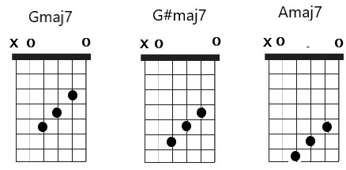
|---------|--------------------------------------------------------------------|
|---------|---------------------10-11-12--12-13-14--14-14-15-15-15-15-14-15----|
|-9-11-12-|-9-9-9-11-11-11--12-------------------------------------------------|
|---------|----------------------7--8--9---9-10-11--11-11-12-12-12-12-11-12----|
|-7--9-10-|-7-7-7--9--9--9--10-------------------------------------------------|
|---------|--------------------------------------------------------------------|

|--------------------15-14-12-10-14----|
|-17-17-17-17-15-17--------------------|
|--------------------12-11--9--7-11----|
|-14-14-14-14-12-14--------------------|
|--------------------------------------|
|--------------------------------------|

