**Bus Stop The Hollies edited 10/18/2024**

**[Intro]**

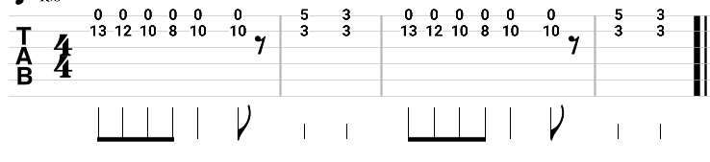

**[Verse 1]**

**Am**

**Bus stop, wet day, she's there, I say**

**Am**

**Please share my umbrella**

**Am**

**Bus stop, bus goes, she stays, love grows**

**Am G**

**Under my umbrella**

**C G Am Dm Em**

**All that summer we enjoyed it Wind and rain and shine**

**Am Em Am**

**That umbrella, we employed it By August, she was mine**

**[Chorus]**

**C B7 Em C**

**Every morning I would see her waiting at the stop**

**Am B7 Em**

**Sometimes she'd shopped and she would show me what she bought**

**C B7 Em C**

**All the people stared as if we were both quite insane**

**Am B7 Em**

**Someday my name and hers are going to be the same**

**[Verse 2]**

**Am**

**That's the way the whole thing started Silly but it's true**

**Am**

**Thinkin' of a sweet romance Beginning in a queue**

**C G Am Dm Em**

**Came the sun the ice was melting No more sheltering now**

**Am Em Am**

**Nice to think that that umbrella Led me to a vow**

**[Solo]**

**Am 8x**

**[Chorus]**

**C B7 Em C**

**Every morning I would see her waiting at the stop**

**Am B7 Em**

**Sometimes she'd shopped and she would show me what she bought**

**C B7 Em C**

**All the people stared as if we were both quite insane**

**Am B7 Em**

**Someday my name and hers are going to be the same**

**[Verse 3]**

**Am**

**Bus stop, wet day, she's there, I say Please share my umbrella**

**Am G**

**Bus stop, bus goes, she stays, love grows Under my umbrella**

**C G Am Dm Em**

**All that summer we enjoyed it Wind and rain and shine**

**Am Em Am**

**That umbrella, we employed it By August, she was mine**

**[Coda]**

**Am 8x**

**SOLO**

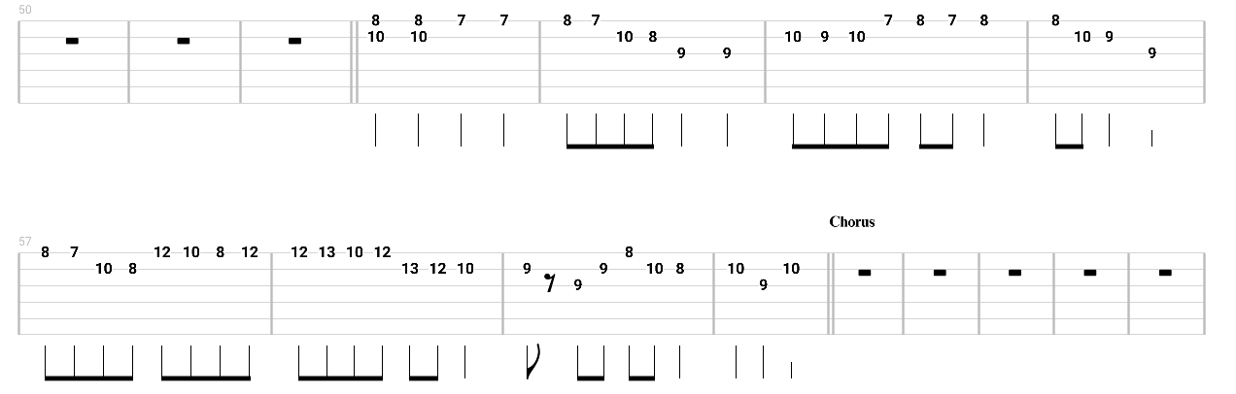

**CODA**

