**EIGHT DAYS A WEEK the Beatles edited 01/05/2024**

**Intro: D D E7sus2 D single chords, then same for E, G and D**

**See notes below**

**[Verse 1]**

**D E G D**

**Ooh I need your love babe Guess you know it's true**

**D E G D**

**Hope you need my love babe Just like I need you**

**Bm G6 Bm E**

**Hold me, love me Hold me, love me**

**D E G D**

**Ain't got nothin' but love babe Eight days a week**

**[Verse 2]**

**D E G D**

**Love you every day girl Always on my mind**

**D E G D**

**One thing I can say girl Love you all the time**

**Bm G6 Bm E**

**Hold me, love me Hold me, love me**

**D E G D**

**Ain't got nothin' but love babe Eight days a week**

**[Refrain]**

**A Bm tacet**

**Eight days a week I love you**

**E G6 A**

**Eight days a week Is not enough to show I care**

***[Verse 1]***

***[Refrain]***

***[Verse 2]***

**G D**

**Eight days a week**

**G D**

**Eight days a week**

**OUTRO SAME AS INTRO**

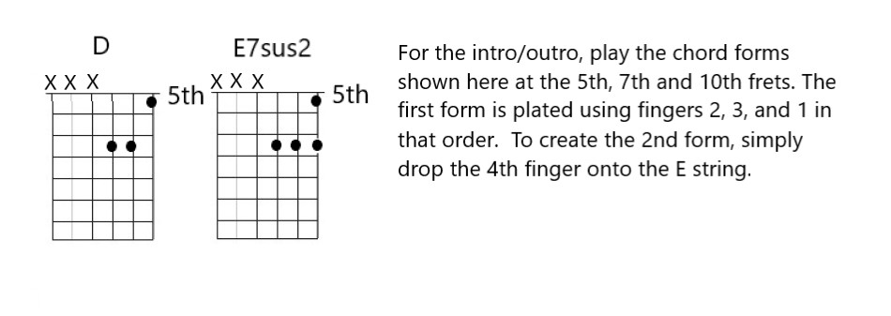

**Outro: D / E7 / G / D /**