**A HARD DAY'S NIGHT The Beatles edited 03/29/2022**

**[Intro]**

**G chord Tacet sustained – see notes**

**[Verse 1]**

**G Cadd G F G**

**It's been a hard day's night and I've been working like a dog**

**G Cadd9 G F G**

**It's been a hard day's night I should be sleeping like a log**

**C D**

**But when I get home to you I find the things that you do**

**G C9 G**

**Will make me feel a- al-right**

**[Verse 2]**

**G Cadd9 G F G**

**You know I work all day to get you money to buy things**

**G Cadd9 G F G**

**And It's worth it just to hear you say you're gonna give me everything**

**C D**

**So why on earth should I moan 'cause when I get you alone**

**G C9 G**

**You know I'll feel O. K.**

**[Chorus 1]**

**Bm Em Bm**

**When I’m home everything seems to be right**

**G Em C9 D**

**When I'm home feeling you holding me tight, tight, yeah**

**[Verse 1]**

**[solo]]**

**G Cadd9 G F G**

**G Cadd9 G F G**

**C D**

**So why on earth should I moan 'cause when I get you alone**

**G C9 G**

**You know I'll feel O. K.**

**[Chorus 2]**

**Bm Em Bm**

**When I’m home everything seems to be right**

**G Em C7 D7(9)**

**When I'm home feeling you holding me tight, tight, yeah**

**[Verse 1]**

**[Coda]**

**G C9 G**

**You know I feel alright**

**G C9 G**

**You know I feel alright**

**-3-------1--------3---------1----------**

**---1---1---1---1----1----1-----1-----1-**

**-----2-------2--------2-----------2---- End on a G chord**

**---------------------------------------**

**---------------------------------------**

**---------------------------------------**

**\*\*\*\*\*\*\*\*\*\*\*\*\*\*\*\*\*\*\*\*\*\*\*\*\*\*\*\*\*\*\*\*\*\*\*\*\*\*\*\*\*\*\*\*\*\*\*\*\*\*\*\*\*\*\*\*\*\*\*\*\*\*\*\*\*\*\*\*\***

**Notes**

**For the Intro, the most commonly used chord is the G7sus4. You can also play a G or a G(add11), or have multiple guitarists play different versions of the G chord simultaneously.**

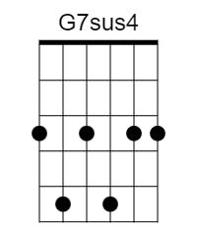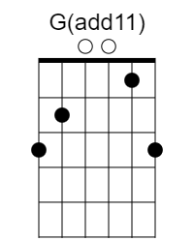

**“Beatles’ Chords”**

**These versions of the chords make playing the verses easy, with a minimum of finger movement. And the D7(9) is just the C7 slid up a step.**

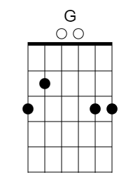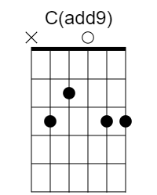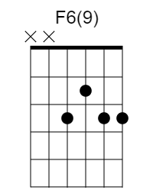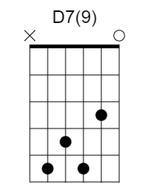

**[Solo tab] V1**

**--------------------------------1------1------1------------------**

**---------------1----1h3-----1h3----1h3----1h3----1h3p1-----------**

**---0---0---3------3-------------------------------------0--0-----**

**-----------------------------------------------------------------**

**-----------------------------------------------------------------**

**-----------------------------------------------------------------**

**[Solo tab] V2**

**|--------------------------------------------------|**

**|--------------------------------------------------|**

**|---------------------9------9------9--------------|**

**|------7h9-7-/11-9h11---9h11---9h11---11p9\-7------|**

**|-/9-9----------------------------------------9----|**

**|--------------------------------------------------|**