**Heart Full Of Soul The Yardbirds edited 10/18/2024**

**[Intro]**

**Dm Dsus4 4x**

**[Verse 1]**

**Dm G Bb**

**Sick at heart and lonely,**

**Dm**

**deep in dark despair.**

**G Bb**

**Thinking one thought only**

**Dm**

**where is she tell me where.**

**G Bb**

**And if she says to you**

**Dm**

**she don't love me**

**G Bb**

**just give her my message**

**Dm**

**tell her of my plea**

**[Chorus]**

**Dm F G Dm**

**And I know if she had me back again**

**Bb F D**

**well I would never make her sad.**

**A G Dm**

**I've gotta hea-a-a-art full of soul.**

**Dm Dsus4 2x**

**[Solo]**

**Dm G Bb Dm G Bb Dm**

**[Chorus]**

**Dm F G Dm**

**And I know if she had me back again**

**Bb F D**

**well I would never make her sad.**

**A G Dm**

**I've gotta hea-a-a-art full of soul.**

**Dm Dsus4 2x**

**[Verse 2]**

**Dm G Bb**

**She's been gone such a long time**

**Dm**

**longer than I can bear**

**G Bb**

**but if she says she wants me**

**Dm**

**tell her that I'll be there**

**G Bb**

**And if she says to you**

**Dm**

**she don't love me**

**G Bb**

**just give her my message**

**Dm**

**tell her of my plea.**

**[Chorus]**

**Dm F G Dm**

**And I know if she had me back again**

**Bb F D**

**well I would never make her sad.**

**A G Dm**

**I've gotta hea-a-a-art full of soul.**

**[Coda]**

**Dm Dsus4 3X Dm**

**Main Riff**

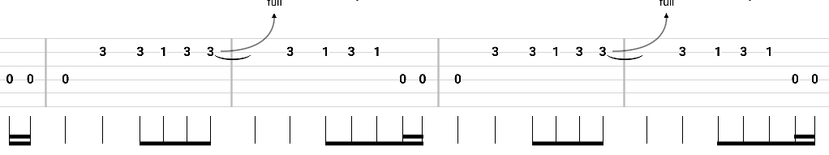

**Solo**

