THE LAST TIME by THE ROLLING STONES edited 11/18/2022

[intro]

E D A E D A

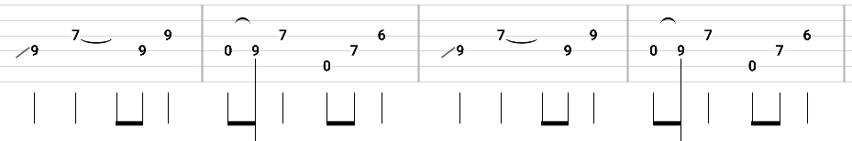

[verse 1]

E D A EDA

Well I told you once and I told you twice

E D A EDA

But you never listen to my advice

E D A EDA

You don't try very hard to please me

E D A EDA

For what you know it should be easy

[CHORUS] (strum chords)

A A

Well this could be the last time

A A

This could be the last time

D A

Maybe the last time I don't know

EDA EDA

Oh no Oh no

[verse 2]

E D A EDA

Well I'm sorry girl but I can't stay

E D A EDA

Feelin' like I do today

E D A EDA

Theres too much pain and too much sorrow

E D A EDA

Guess I'll feel the same tomorrow

[CHORUS]

[Solo] E [9] D [7] A [5] E

|-2x

E [9] D [7] A [5] E [9]

[CHORUS]

[verse 3]

E D A EDA

Well I told you once and I told you twice

E D A EDA

Some will have to pay the price

E D A EDA

Heres a chance to change your mind

E D A EDA

Cause I'll be gone a long, long time

[CHORUS]

[Coda]

E D A

Could be the last time No No No x4

