The Letter The Box Tops edited 11/17/2022

[Intro]

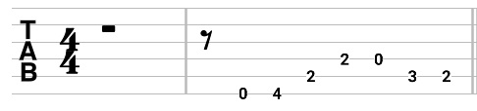

[Verse 1]
Am F
Give me a ticket for an aeroplane
G D
Ain't got time to take a fast train
Am F
Lonely days are gone, I'm a-goin' home
E Am
Cause my baby just wrote me a letter

[Verse 2]
Am F
I don't care how much money I gotta spend
G D
Got to get back to my baby again
Am F
Lonely days are gone, I'm a-goin' home
E Am
My baby just wrote me a letter

[Chorus]
C G
Well she wrote me a letter
F C G
Said she couldn't live without me no more
C G
Listen mister can't you see
F C G
I got to get back to my baby once more
E tacet
Anyway

[Verse 1]

[Chorus]

[Verse 1]
E Am
my baby just wrote me a letter

[Coda]
C# G# F# C# G# 4 end on the G#
Ooo ooo ooo ooo oooooo (and/or jet sounds)

