**Love Is All Around The Troggs edited 10/23/2023**

**[Intro]**

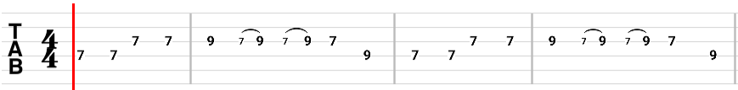

**[Verse 1]**

**D Em G A D Em G A**

**I feel it in my fingers, I feel it in my toes**

**D Em G A D Em G A**

**Well, love is all a round me and so the feeling grows**

**D Em G A D Em G A**

**It's written on the wind, it's every where I go**

**D Em G A D Em G A**

**So if you really love me, come on and let it show**

**[Bridge]**

**e |------------------|**

**B |------------------|**

**G |---4--2-----------|**

**D |---4--2---4--0-2--|**

**A |----------4--0-2--|**

**E |------------------|**

**[CHORUS]**

**G Em**

**You know I love you I always will**

**G D**

**My mind's made up by the way that I feel**

**G Em**

**There's no beginning, there'll be no end**

**Em A**

**'Cause on my love you can depend**

**A |--0--2--4--|**

**[Verse 2]**

**D Em G A D Em G A**

**I see your face before me, as I lay on my bed**

**D Em G A D Em G A**

**I kinda get to thinking of all the things you said**

**D Em G A D Em G A**

**You gave your promise to me, and I gave mine to you**

**D Em G A D Em G A**

**I need someone beside me in everything I do**

**[Bridge]**

**[CHORUS]**

**A |--0--2--4--|**

**[Verse 3 and end]**

**D Em G A D Em G A**

**It's written on the wind, it's everywhere I go**

**D Em G A D Em**

**So if you really love me, come on and let it show**

**G A D Em**

**Come on and let it show**

**G A D Em G A D**

**Come on and let it show**