# Mary Jane’s Last Dance Tom Petty edited 10/18/2024

**[Intro]**

**Am G Dsus2 Am (x4)**

**[Verse]**

**Am G**

**She grew up in an Indiana town**

**Dsus2 Am**

**Had a good-lookin' mama who never was around**

**Am G**

**But she grew up tall and she grew up right**

**Dsus2 Am**

**With them Indiana boys on them Indiana nights**

**Am G Dsus2 Am (x2) w/harmonica**

**[Verse 2]**

**Am G**

**Well she moved down here at the age of eighteen**

**Dsus2 Am**

**She blew the boys away, was more than they'd seen**

**Am G**

**I was introduced and we both started groovin'**

**Dsus2 Am**

**She said, "I dig you baby but I got to keep movin'"**

**Am G Dsus2 Am**

**on, keep movin' on**

**Am G Dsus2 Am**

**[Chorus]**

**Em7**

**Last dance with Mary Jane**

**Em7 A (Chorus part 1)**

**One more time to kill the pain**

**Em7**

**I feel summer creepin' in and I'm**

**Em7 A (chorus part 2) ends on G**

**Tired of this town again**

**[Harmonica Solo]**

**Am G Dsus2 Am (x2) w/harmonica**

**[Verse 3]**

**Am G**

**Well I don't know, but I've been told**

**Dsus2 Am**

**You never slow down, you never grow old**

**Am G**

**I'm tired of screwing up, I'm tired of going down**

**Dsus2 Am**

**Tired of myself, tired of this town**

**Am G**

**Oh my my, oh hell yes**

**Dsus2 Am**

**Honey put on that party dress**

**Am G**

**Buy me a drink, sing me a song,**

**Dsus2 Am**

**Take me as I come 'cause I can't stay long**

**[Chorus]**

**Em7**

**Last dance with Mary Jane**

**Em7 A (Chorus part 1)**

**One more time to kill the pain**

**Em7**

**I feel summer creepin' in and I'm**

**Em7 A (chorus part 2) ends on G**

**Tired of this town again**

**[Guitar Solo]**

**Am G Dsus2 Am (x4)**

**[Verse 4]**

**Am G**

**There's pigeons down on Market Square**

**Dsus2 Am**

**She's standin' in her underwear**

**Am G**

**Lookin' down from a hotel room**

**Dsus2 Am**

**Nightfall will be comin' soon**

**Am G**

**Oh my my, oh hell yes**

**Dsus2 Am**

**You got to put on that party dress**

**Am G**

**It was too cold to cry when I woke up alone**

**Dsus2 Am**

**I hit my last number and walked to the road**

**[Chorus]**

**Em7**

**Last dance with Mary Jane**

**Em7 A (Chorus part 1)**

**One more time to kill the pain**

**Em7**

**I feel summer creepin' in and I'm**

**Em7 A (chorus part 2) ends on G**

**Tired of this town again**

**[Coda]**

**Am G Dsus2 Am (x 12)**

**Chorus part 1**

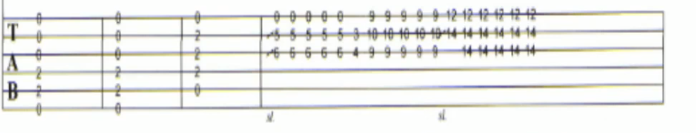

**Chorus part 2**

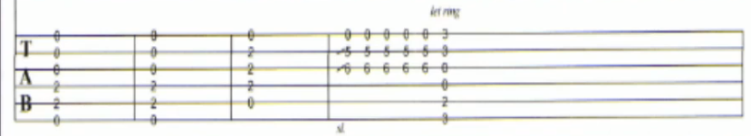

**Solo part 1**

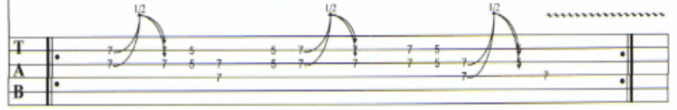

**Solo part 2**

