**WITH A LITTLE HELP FROM MY FRIENDS- The Beatles edited 10/18/2024**

**Intro C D E (bill-y shears)**

**[Verse 1]**

**E B F#m**

**What would you think if I sang out of tune**

**B7 E**

**Would you stand up and walk out on me?**

**B F#m**

**Lend me your ears and I'll sing you a song**

**B7 E**

**And I'll try not to sing out of key**

**[CHORUS]**

**D A E**

**Oh, I get by with a little help from my friends**

**D A E**

**Mm, I get high with a little help from my friends**

**A E B7**

**Mm, gonna try with a little help from my friends**

**[Verse 2]**

**E B F#m B7 E**

**What do I do when my love is away (Does it worry you to be alone?)**

**B F#m**

**How do I feel by the end of the day**

**B7 E**

**(Are you sad because you're on your own?)**

**[CHORUS]**

**D A E**

**No, I get by with a little help from my friends**

**D A E**

**Mm, I get high with a little help from my friends**

**A E**

**Mm, gonna try with a little help from my friends**

**[BRIDGE]**

**E C#m F#m7 E D A**

**(Do you need anybody?) I need somebody to love**

**C#m F#m7 E D A**

**(Could it be anybody?) I want somebody to love**

**[Verse 3]**

**E B F#m**

**(Would you believe in a love at first sight)**

**B7 E**

**Yes, I'm certain that it happens all the time**

**E B F#m**

**(What do you see when you turn out the light)**

**B7 E**

**I can't tell you but I know it's mine**

**[CHORUS]**

**D A E**

**No, I get by with a little help from my friends**

**D A E**

**Mm, I get high with a little help from my friends**

**A E**

**Mm, gonna try with a little help from my friends**

**[BRIDGE]**

**E C#m F#m7 E D A**

**(Do you need anybody?) I just need someone to love**

**C#m F#m7 E D A**

**(Could it be anybody?) I want somebody to love**

**[Coda]**

**A D A E**

**Oh, I get by with a little help from my friends**

**D A E**

**Mm, I'm gonna try with a little help from my friends**

**D A E**

**Oh I get high with a little help from my friends**

**D A**

**Yes, I get by with a little help from my friends**

**C/G Am6 E**

**With a little help from my friends**

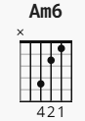

**Intro**

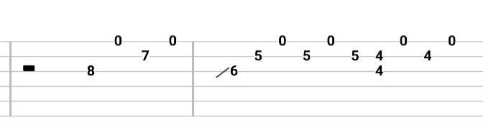

**Between chorus and verse 2**

