love will keep us alive the eagles edited 04/19/2022

[Verse 1]
Asus2 F#m7add11
I was standing… All alone against the world outside…
D6sus2 Esus4 E
You were searching… for a place to hide…
Asus2 F#m7add11
Lost and lonely…Now you given me the will to survive…
D6sus2 Esus4 E Asus2
When we're hungry... love will keep us alive…

[Verse 2]
Asus2 F#m7add11
Don't you worry…Sometimes you've just gotta let it ride…
D6sus2 Esus4 E
The world is changing… Right before your eyes…
Asus2 F#m7add11
Now I've found you…There's no more emptiness inside…
D6sus2 Esus4 E Asus2
When we're hungry... love will keep us alive…

[Bridge]
D F#m7
I would die for you…Climb the highest mountain…
Bm7 E E/D E6/C# E/B
Baby, there's nothing I wouldn't do…

[Verse 3]
Asus2 F#m7add11
Now I've found you…There's no more emptiness in-side…
D6sus2 Esus4 E Asus2
When we're hungry... love will keep us alive…

[Solo]
Asus2 F#m7add11 D6sus2 Asus2

[Bridge]

[Verse 4]
Asus2 F#m7add11
I was standing… All alone against the world outside…
D6sus2 Esus4 E
You were searching… for a place to hide…
Asus2 F#m7add11
Lost and lonely…Now you given me the will to survive…
D6sus2 Esus4 E Asus2 F#m7add11
When we're hungry... love will keep us alive…

[Coda]
D6sus2 Esus4 E Asus2 F#m7add11
When we're hungry... love will keep us alive…
D6sus2 Esus4 E Asus2
When we're hungry... love will keep us alive…

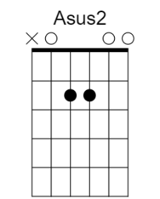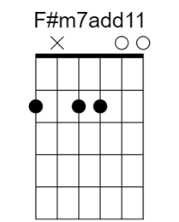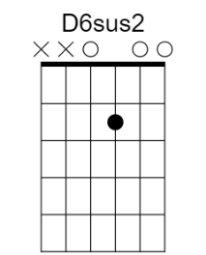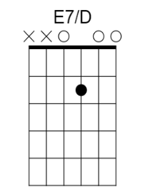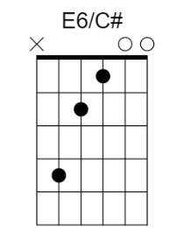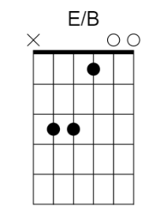

Asus2 - x02200 F#m7add11 - 2x2200 D6sus2 - xx0200 Esus4 - 022200
E7/D - xx0100 E6/C# - x42100 E/B - x22100
--------------------------------------------------------------------------

