**Shakin’ All Over - The Who arrangement edited 11/17/2022**

**[Intro riff]**

Em

**[Verse 1]**

## **Em**

**When you move in right up close to me**

## **Em**

**That's when I get the shakes all over me**

## **Em Am**

**Quivers down my back bone**

## **Em**

**I've got the shakes down the backbone**

## **Am Em**

**I got the shivers in my knee bone (quivers in my thigh bones)**

## **Em**

**Shakin' all over**

**Em {intro riff} 2x**

**[Verse 2]**

## **Em**

**Just the way you say goodnight to me**

## **Em**

**Brings that feeling on inside of me**

## **Em Am**

**Quivers down my back bone**

**Em**

**I've got the shakes down the backbone**

## **Am**

**I got the shivers in my knee bone (quivers in my thigh bones)**

## **Em**

**Shakin' all over**

**[Solo]**

**A**

**A Asus4 A Aadd2**

**A Asus4 G5 G5/F#**

**A Asus4 A Aadd2**

**A Asus4 G5 G5/F#**

**A**

**A G5 D [5x]**

# A

**E Em11 D A5 E Em11 D A5 E Em11**

**[Coda]**

## **Em Am**

**Quivers down my back bone**

**Em**

**I've got the shakes down the backbone**

**Am**

**I got the shivers in my knee bone**

## **Em**

**Shakin' all over**

**{intro riff}**

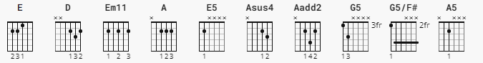

**[Intro Riff] [main pattern ]**

**|-3p0-------------| |------------------||-----------------||-------------------|**

**|-----3-0---------| |------------------||-----------------||-------------------|**

**|---------2-0-----| |------------------||--------------2^-||-----2-0---0-------|**

**|-------------2-0-| |-----2-2-0-*0-----||-----2-2-0-*0*---||---------2----0----|**

**|-----------------| |--------------2-2-||-----------------||-------------------|**

**|-----------------| |-0-0--------------||-0-0-------------||----------------3^-|**